

**(CT038-3-2-OODJ)**

**OBJECT ORIENTED DEVELOPMENT WITH JAVA**

**GROUP ASSIGNMENT**

**INTAKE CODE : APU2F2502CS(CYB)**

**LECTURER : Tan Li June**

**HAND OUT DATE : 25 March 2025**

**HAND IN DATE : 3 June 2025**

**GROUP : Group 33 (LAB 8)**

|  |  |
| --- | --- |
| **Student ID** | **Student Name** |
| TP080121 | Yaw Kai Yuan |
| TP080509 | Voon Yue Cheng |
| TP080254 | Er Chen Liang |
| TP077723 | Huang Xiao Shun |
| TP080388 | Chong Wai Kit |

Table of Contents

1.0 Introduction 4

2.0 UML Diagram 5

2.1 Use-case Diagram 5

2.1.1 Use Case Specification Table 6

2.2 Class Diagram 21

3.0 Output of Program 22

3.1 Login 22

3.2 Sales Manager 26

3.3 Purchase Manager 59

3.4 Administrator 75

3.5 Inventory Manager 78

3.6 Finance Manager 99

4.0 Object Oriented Concepts 112

4.1 Encapsulation 112

4.2 Inheritance 117

4.3 Polymorphism 120

4.3.1 Overriding 120

4.3.2 Overloading 124

4.4 Abstraction 127

4.4.1 Abstracts 127

4.4.2 Interfaces 128

5.0 Additional Features 130

5.1 Finance Manager Monthly Budget Features 130

5.2 Finance Manager Supplier Performance Report 133

6.0 Limitation 134

7.0 Conclusion 135

8.0 Workload Matrix 136

9.0 References 137

# 1.0 Introduction

The objective of this assignment is to develop an automated purchase order management system for Omega Wholesale Sdn Bhd (OWSB). There are 5 types of users who can access this system. The Sales Manager is responsible for managing items, suppliers, daily itemized sales and issuing purchase requisitions. The Purchasing Manager is responsible for reviewing purchase requisitions and generating purchase orders. The Administrator has the highest level of access and is responsible for the overall management of the system and user creation. The Inventory Manager is responsible for updating inventory based on approved purchase orders, monitoring inventory levels and generating alerts when inventory levels are low. In addition, inventory reports are generated to record inventory status. The Finance Manager is responsible for verifying inventory updates before payment is made via purchase orders and then processing payments to suppliers. In addition, financial reports are generated to record financial status.

Omega Wholesale Sdn Bhd (OWSB)'s Purchase Order Management System is developed using the Java programming language and is based on Object Oriented Programming (OOP) principles. For efficiency, the system is designed based on OOP concepts such as encapsulation, inheritance, polymorphism, and abstraction.

In this assignment, we assume that each object has a unique ID. For example, five users are represented by S for Sales Manager, P for Purchase Manager, A for Administrator, I for Inventory Manager, and F for Finance Manager, followed by IDs from 001 to 999. Other objects such as Purchase Requisitions are PR, Purchase Orders are PO, Items are ITEM, Sales Entries are SE, Suppliers are SUP, followed by IDs from 001 to 999.

# 2.0 UML Diagram

## 2.1 Use-case Diagram

Figure 1 - Use case diagram for automated purchase order management system

The administrator actually needs to be connected to all use cases, but due to layout reasons, the administrator is not connected to all use cases.

## 2.1.1 Use Case Specification Table

|  |  |
| --- | --- |
| **Use Case** | Login |
| **Brief Description** | Allows a registered user to access the system by providing valid credentials. |
| **Actors** | Sales Manager, Purchase Manager, Administrator, Inventory Manager, Finance Manager |
| **Preconditions** | The user must already have an account with a valid user ID and password stored in user_account.txt. |
| **Main Flow** | (a) User enters user ID and password.  (b) System validates format of user ID and password.  (c) System authenticates user against stored records.  (d) If credentials are valid, user is directed to their role-specific main menu. |
| **Alternative Flows** | (b) (i) If the User ID or Password format is invalid, for example, the User ID is not the first letter of the role followed by 3 numbers, an error message will appear.  (c) (ii) If the User ID or Password is incorrect, an error dialog is displayed. |

Table 1 - Login

**Sales Manager**

|  |  |
| --- | --- |
| **Use Case** | View Item Entry |
| **Brief Description** | Allow a sales manager to view, add, edit, and delete the item entry details which show the item entry details in a table. |
| **Actors** | Sales Manager |
| **Preconditions** | The sales manager is authenticated in the system, and the sales manager must have granted permissions for these operations. |
| **Main Flow** | (a) Sales manager login to the system.  (b) Sales manager clicks on the Item Entry button in the system.  (c) The system will show the item entry details in a table.  (d) Sales manager can do the following actions:   * Add Item Entry * Edit Item Entry * Delete Item Entry   (e) The system confirms the action given by the sales manager and updates the table data. |
| **Alternative Flows** | (d) (i) If sales manager enters incorrect data type in the quantity text box, it will meet a data validation error.  (d) (ii) If sales manager types a wrong item id and tries to edit or delete it, it will show “Item ID not found” in a dialog box. |

Table 2 - View Item Entry

|  |  |
| --- | --- |
| **Use Case** | View Supplier Entry |
| **Brief Description** | Allow a sales manager to view, add, edit, and delete the supplier details which show the supplier details in a table. |
| **Actors** | Sales Manager |
| **Preconditions** | The sales manager is authenticated in the system, and the sales manager must have granted permissions for these operations. |
| **Main Flow** | (a) Sales manager login to the system.  (b) Sales manager clicks on the Supplier Entry button in the system.  (c) The system will show the supplier details in a table.  (d) Sales manager can do the following actions after getting permission:   * Add Supplier * Edit Supplier * Delete Supplier   (e) The system confirms the action given by the sales manager and updates the table data. |
| **Alternative Flows** | (d) (i) If sales manager enters incorrect data type in the unit price text box, it will meet a data validation error.  (d) (ii) If sales manager types a wrong supplier id and tries to edit or delete it, it will show “Supplier ID not found” in a dialog box. |

Table 3 - View Supplier Entry

|  |  |
| --- | --- |
| **Use Case** | View Daily Item-Wise Sales Entry |
| **Brief Description** | Allow a sales manager to view, add, edit, and delete the sales entry details which show the sales entry details in a table. |
| **Actors** | Sales Manager |
| **Preconditions** | The sales manager is authenticated in the system, and the sales manager must have granted permissions for these operations. |
| **Main Flow** | (a) Sales manager login to the system.  (b) Sales manager clicks on the Item-Wise Sales Entry button in the system.  (c) The system will show the sales entry details in a table.  (d) Sales manager can do the following actions:   * Add Sales Entry * Edit Sales Entry * Delete Sales Entry   (e) The system confirms the action given by the sales manager and updates the table data. |
| **Alternative Flows** | (d) (i) If sales manager enters incorrect data type in the quantity text box, it will meet a data validation error.  (d) (ii) If sales manager types a wrong sales entry id and tries to edit or delete it, it will show “Sales entry ID not found” in a dialog box. |

Table 4 - View Daily Item-Wise Sales Entry

|  |  |
| --- | --- |
| **Use Case** | View Purchase Requisition |
| **Brief Description** | Allow a sales manager to view, add, edit, and delete the purchase requisition details which show the purchase requisition details in a table. |
| **Actors** | Sales Manager |
| **Preconditions** | The sales manager is authenticated in the system, and the sales manager must have granted permissions for these operations. |
| **Main Flow** | (a) Sales manager login to the system.  (b) Sales manager clicks on the Purchase Requisition button in the system.  (c) The system will show the purchase requisition details in a table.  (d) Sales manager can do the following actions:   * Add Purchase Requisition * Edit Purchase Requisition * Delete Purchase Requisition   (e) The system confirms the action given by the sales manager and updates the table data. |
| **Alternative Flows** | (d) (i) If sales manager enters incorrect data type in the quantity text box, it will meet a data validation error.  (d) (ii) If sales manager types a wrong purchase requisition id and tries to edit or delete it, it will show “purchase requisition ID not found” in a dialog box. |

Table 5 - View Purchase Requisition

|  |  |
| --- | --- |
| **Use Case** | View Purchase Order |
| **Brief Description** | Allow a sales manager to view and search the purchase order details which show the purchase order details in a table. |
| **Actors** | Sales Manager |
| **Preconditions** | The sales manager is authenticated in the system. |
| **Main Flow** | (a) Sales manager login to the system.  (b) Sales manager clicks on the View Purchase Order button in the system.  (c) The system will show the purchase order details in a table.  (d) Sales manager can search the purchase order by enter the purchase order id and the following purchase requisition id.  (e) The system will show the purchase order details in a table according to the search of the sales manager. |
| **Alternative Flows** | (d) (i) If sales manager types a wrong purchase requisition id and tries to search it, it will show “purchase requisition ID not found” in a dialog box. |

Table 6 - View Purchase Order

**Purchase Manager**

|  |  |
| --- | --- |
| **Use Case** | View Items |
| **Brief Description** | Purchase Manager can view the items detail from the created database |
| **Actors** | Purchase Manager |
| **Preconditions** | Purchase Manager log in successfully |
| **Main Flow** | a) User log in as Purchase Manager successfully  b) Purchase Manager click on the View Items button |
| **Alternative Flows** | - |

Table 7 - View Items

|  |  |
| --- | --- |
| **Use Case** | View Suppliers |
| **Brief Description** | Purchase Manager can view supplier details, such as supplier id, item info and unit price |
| **Actors** | Purchase Manager |
| **Preconditions** | Purchase Manager log in successfully |
| **Main Flow** | a) User log in as Purchase Manager successfully  b) Purchase Manager click on the View Suppliers button |
| **Alternative Flows** | - |

Table 8 - View Suppliers

|  |  |
| --- | --- |
| **Use Case** | View Purchase Requisitions |
| **Brief Description** | Purchase Manager can view Purchase Requisition which generated by Sales Manager to confirm purchase order |
| **Actors** | Purchase Manager |
| **Preconditions** | Purchase Manager log in successfully |
| **Main Flow** | a) User log in as Purchase Manager successfully  b) Purchase Manager click on the View Requisition button |
| **Alternative Flows** | - |

Table 9 - View Purchase Requisitions

|  |  |
| --- | --- |
| **Use Case** | View Purchase Order |
| **Brief Description** | Allow Purchase Manager to view, add, edit and delete purchase order |
| **Actors** | Purchase Manager |
| **Preconditions** | -Purchase Manager log in successfully  -There don't have any purchase requisition allow to make an order |
| **Main Flow** | a) User log in as Purchase Manager successfully  b) Purchase Manager click on the Generate Purchase Order button  c) Purchase Manager can do these actions:  - Add Purchase Order  - Delete Purchase Order  - Edit Purchase Order  d) System will confirm the request by Purchase Manager and updates the data into the table |
| **Alternative Flows** | c) i) If Purchase Manager type a wrong data type in quantity text box, system will show data validation error |

Table 10 - View Purchase Order

**Administrator**

|  |  |
| --- | --- |
| **Use Case** | View User |
| **Brief Description** | Administrator views the list of existing users in the system. Other user actions such as Add, Edit, and Delete are extended from this view |
| **Actors** | Administrator |
| **Preconditions** | Administrator must be logged in to the system successfully |
| **Main Flow** | 1. Administrator opens the Admin panel  2. The system displays the list of registered users in a table  3. Administrator can review the user list |
| **Alternative Flows** | If no users exist, the table will be empty or show a message like “No users found.” |

Table 11 - View User

**Inventory Manager**

|  |  |
| --- | --- |
| **Use Case** | View Item |
| **Brief Description** | Inventory Manager can view items following the details generated from item database. |
| **Actors** | Inventory Manager |
| **Preconditions** | 1. Inventory Manager must be logged into the system successfully 2. Item list database must exist |
| **Main Flow** | 1. Navigate to “View Item List” page 2. The system displays a list of items followed with the item details |
| **Alternative Flows** | None |

Table 12 - View Item

|  |  |
| --- | --- |
| **Use Case** | View Purchase Order |
| **Brief Description** | Inventory Manage can view details of selected purchase order. If the purchase order is approved and not yet updated to the stock, inventory manager can verify received item quantity and update to the stock. |
| **Actors** | Inventory Manager |
| **Preconditions** | 1. Inventory Manager must be logged into the system successfully 2. Purchase order database must exist |
| **Main Flow** | 1. Navigate to “View Purchase Order” page 2. Enter the purchase order ID wanted to be searched then click “Search” button 3. The system displays the purchase order searched along with the details and status |
| **Alternative Flows** | 1. i) If the purchase order ID entered does not exist or is invalid, the system shows the message saying the purchase order does not exist and asking the user to enter a valid purchase order ID. 2. ii) If user did not enter anything and clicked “Search” button, the system shows a message telling the user to enter a valid purchase order ID first. 3. i) If status is “Approved”, meaning that the purchase order is approved by finance manager, the “Update Stock” button will appear. The user can enter received amount then click on “Update Stock” button to update the received amount to the stock. 4. ii) If status is “Rejected”, meaning the purchase order is rejected by finance manager, the “Update Stock” button will not appear. The user can only view the purchase order. 5. iii) If status is “Received”, meaning the purchase order is approved by finance manager and the received amount is already updated to stock. The “Update Stock” button will not appear. The user can only view the purchase order. 6. iv) If status is “Error”, meaning the purchase order is approved by finance manager and the received amount is updated to stock, but the received amount does not match the purchased amount. The “Update Stock” button will not appear. The user can only view the purchase order. 7. v) If status is “Paid”, meaning the purchase order is approved by finance manager and the received amount is already updated to stock. The purchase order transaction has been made by finance manager. The “Update Stock” button will not appear. The user can only view the purchase order. 8. vi) If status is “Pending”, meaning the purchase order not yet approved or rejected by finance manager. The “Update Stock” button will not appear. The user can only view the purchase order. |

Table 13 - View Purchase Order

|  |  |
| --- | --- |
| **Use Case** | Manage Stock Levels |
| **Brief Description** | Inventory manager can add or decrease the amount of item quantity in stock. Low-stock alert can be tracked if item quantity is not more than 10. |
| **Actors** | Inventory Manager |
| **Preconditions** | 1. Inventory Manager must be logged into the system successfully 2. Item list database must exist |
| **Main Flow** | 1. Navigate to “Manage Stock Levels” page 2. The system displays list of items with the details 3. The user can change the quantity of the item and click “Confirm” button to update the database |
| **Alternative Flows** | 1. i) If the user altered the quantity and click “Reset” button, the quantity will be reset to the current quantity. 2. ii) If the user entered a negative number to quantity, the system would show a message saying quantity cannot be negative and reset all quantity to current quantity. |

Table 14 - Manage Stock Levels

|  |  |
| --- | --- |
| **Use Case** | Generate Stock Report |
| **Brief Description** | Inventory can generate stock report of current item details in stock and save the report as a CSV file. |
| **Actors** | Inventory Manager |
| **Preconditions** | 1. Inventory Manager must be logged into the system successfully |
| **Main Flow** | 1. Navigate to “Generate Stock Report” page 2. The system displays report details like, report ID, report type, who generated the report, what date is the report generated and current stock details. 3. The user click “Save” button to save the report into a folder in CSV format |
| **Alternative Flows** | None |

Table 15 - Generate Stock Report

**Finance Manager**

|  |  |
| --- | --- |
| **Use Case** | View Purchase Order |
| **Brief Description** | Allow financial managers to view purchase orders that have been generated. Optional actions include approving, rejecting, or editing the order. |
| **Actors** | Finance Manager |
| **Preconditions** | Finance Manager must be log in to the system.  The purchase order needs to have been generated. |
| **Main Flow** | (a) Navigate to "Purchase Orders" Page  (b) System displays a list of all purchase orders.  (c) Finance Manager can sort/filter/view details. |
| **Alternative Flows** | (c) (i) The finance manager can approve, reject, or edit purchase orders. |

Table 16 - View Purchase Order

|  |  |
| --- | --- |
| **Use Case** | Verify Inventory Updates |
| **Brief Description** | Allows the Finance Manager to verify if items were actually received based on the purchase order. |
| **Actors** | Finance Manager |
| **Preconditions** | Finance Manager must be log in to the system.  Inventory Manager must have submitted actual received quantities. |
| **Main Flow** | (a) Navigate to "Verify Inventory Updates" Page  (b) The system displays a list of all purchase orders with their order status.  (c) The financial manager can filter the purchase orders for items that have been received. |
| **Alternative Flows** | (c) (i) If the purchase order is received, the finance manager will process the payment to the supplier. |

Table 17 - Verify Inventory Updates

|  |  |
| --- | --- |
| **Use Case** | Generate Financial Reports |
| **Brief Description** | Generates summaries of paid/unpaid POs and total expenditure. |
| **Actors** | Finance Manager |
| **Preconditions** | Finance Manager must be log in to the system.  Purchase data must exist in the system. |
| **Main Flow** | (a) Navigate to "Generate Financial Report" Page  (b) Report with total paid/unpaid amounts is displayed. |
| **Alternative Flows** | (b) (i) The financial manager can export the financial report in csv format |

Table 18 - Generate Financial Reports

|  |  |
| --- | --- |
| **Use Case** | View Purchase Requisitions |
| **Brief Description** | Finance manager views Purchase Requisitions submitted by Sales Manager. |
| **Actors** | Finance Manager |
| **Preconditions** | Finance Manager must be log in to the system.  Purchase Requisitions must already exist in system. |
| **Main Flow** | (a) Navigate to "View Purchase Requisitions" Page  (b) System displays a list of all purchase requisitions.  (c) Finance Manager can sort/filter/view details. |
| **Alternative Flows** | (b) (i) If file loading fails, an error dialog is shown: “Unable to load purchase requisitions data.” |

Table 19 - View Purchase Requisitions

|  |  |
| --- | --- |
| **Use Case** | Update Monthly Budget |
| **Brief Description** | Finance manager updates the budget limit for any upcoming month. |
| **Actors** | Finance Manager |
| **Preconditions** | Finance Manager must be log in to the system.  Finance Manager selects a valid (non-past) month. |
| **Main Flow** | (a) Finance Manager selects month.  (b) Enters new budget amount.  (c) System validates and saves. |
| **Alternative Flows** | (a) (i) If selected month is in the past, then will show error dialog.  (b) (i) If amount is invalid system will prompt to re-enter. |

Table 20 - Update Monthly Budget

|  |  |
| --- | --- |
| **Use Case** | View Supplier Performance Report |
| **Brief Description** | This use case allows the Finance Manager to view supplier performance based on fulfillment rate, which is calculated from total ordered vs. total received quantities for each supplier. |
| **Actors** | Finance Manager |
| **Preconditions** | Finance Manager must be log in to the system.  Finance Manager selects a valid (non-past) month. |
| **Main Flow** | (a) Finance Manager selects "Supplier Performance Report" from the menu.  (b) System loads all purchase order data.  (c) System calculates fulfillment rate for each supplier.  (d) System determines a status such as Reliable, Haven’t Received, Need Attention  (e) System displays the report in a table format. |
| **Alternative Flows** | (a) (i) If file loading fails, an error dialog is shown: “Unable to load supplier performance data.” |

Table 21- View Supplier Performance Report

## 2.2 Class Diagram

Figure 2 Class Diagram for Automated Purchase Order Management System

This class diagram shows the design of an automated purchase order management system, which is centred around user roles, purchase requisitions, purchase orders, products, suppliers, and daily sales entry. In class diagrams, composition relationships are used, which are strong associations with a solid diamond appearance. For example, a purchase requisition must be associated with specific materials, suppliers, and sales managers to exist. Another relationship used is generalization (inheritance), for example, User is an abstract superclass, which is generalized by these classes: Adminstrator, SalesManager, PurchaseManager, InventoryManager, FinanceManager. Relationships that connect interfaces or abstract classes are represented by dotted lines with triangles.

# 3.0 Output of Program

## 3.1 Login

Figure 3 - Login Page

This is the login page for the automated purchase order management system.

Figure 4 - Fill Incorrect Format Credentials

When the user enters the wrong format, the text box will turn red and the system will prompt the format.

Figure 5 Fill Correct Format Credentials

Enter the correct format and the red box will disappear.

Figure 6 Show Password

Click the Show Password checkbox to view the password.

Figure 7 Forgot Password

When the user forgets the password, click the Forgot Password label and a window for entering the user ID will pop up.

Figure 8 Password Recovery

After entering, the system will display the password of this user id.

## 3.2 Sales Manager

When we log in as a sales manager, we will come to the sales manager menu.

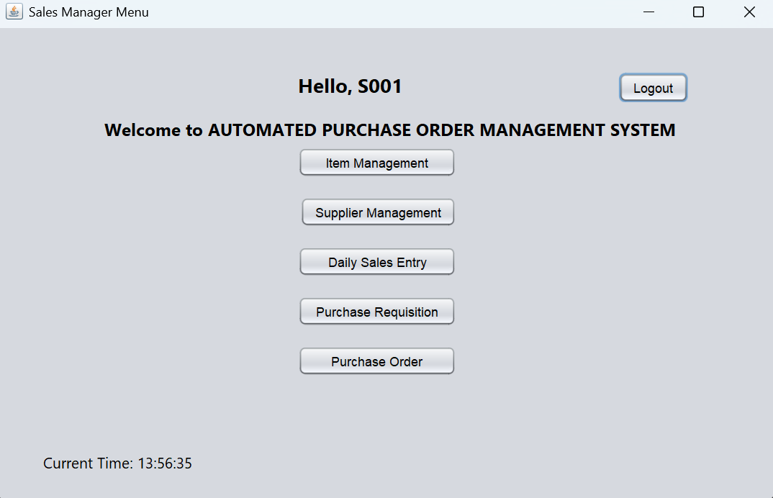

Figure 9 Sales Manager

In the sales manager menu, we can see five buttons at the centre and a log out button on the top right.

**Item Management Page**

We click on the Item Management button to go to the Item Management page.

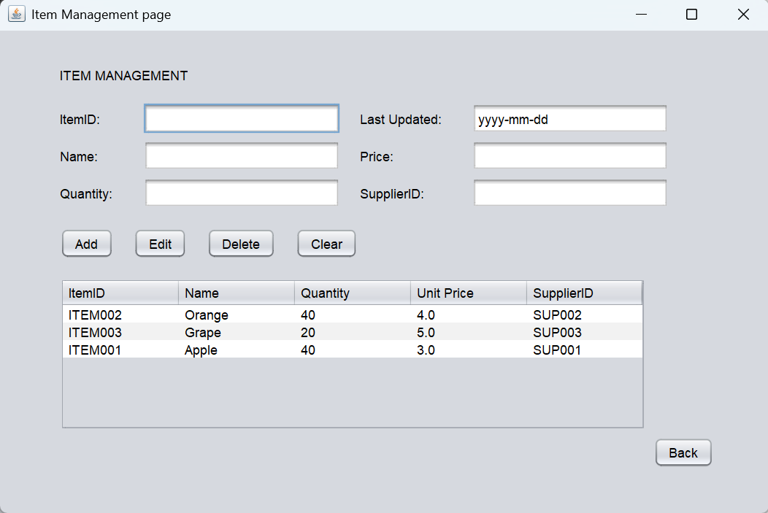

Figure 10 Sales Manager

This is the Item Management page which can allow the sales manager to add, edit and delete the item which was already stored.

Figure 11 Sales Manager

We can enter the details of the new item and click the add button to add the new item.

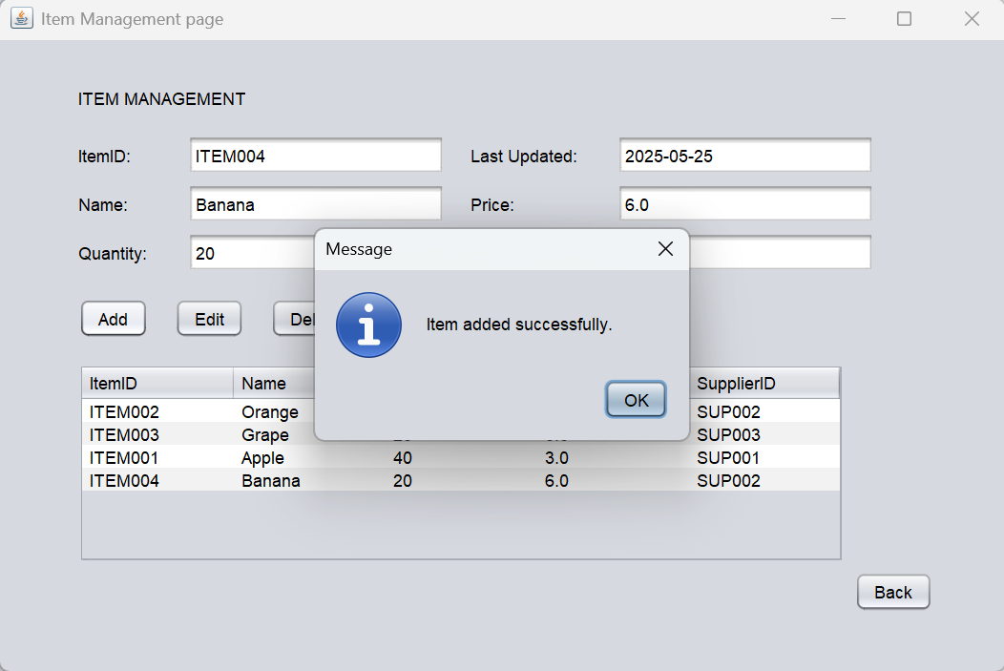

Figure 12 Sales Manager

If the item was added successfully, it will prompt a message box shows that item added successfully then we click the ok button to close the message box. We can see that the new item is showing in the table.

Figure 13 Sales Manager

Next, we can edit the item by clicking the table.

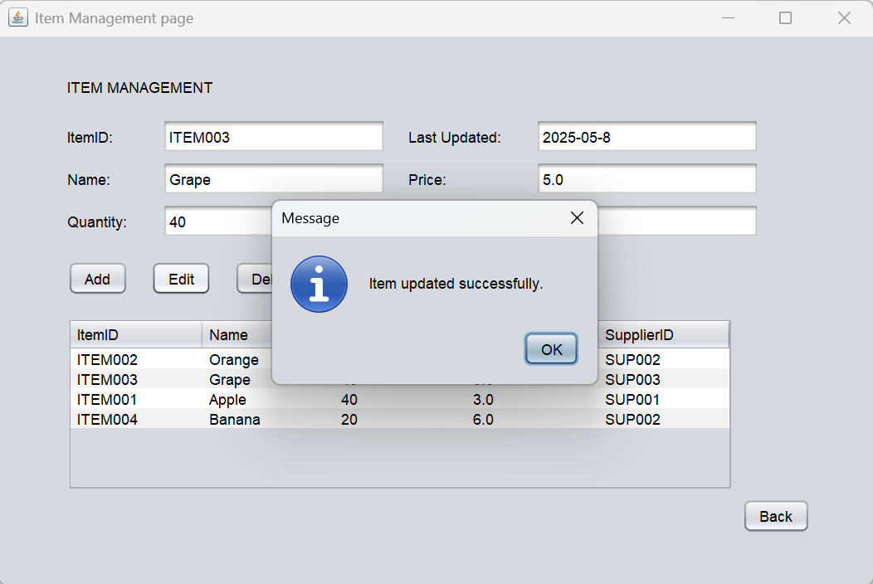

Figure 14 Sales Manager

We edit the quantity of the grape from 20 to 40. And after we click on the Edit button, a message box will prompt and shows that item was updated successfully then we click on the OK to close it.

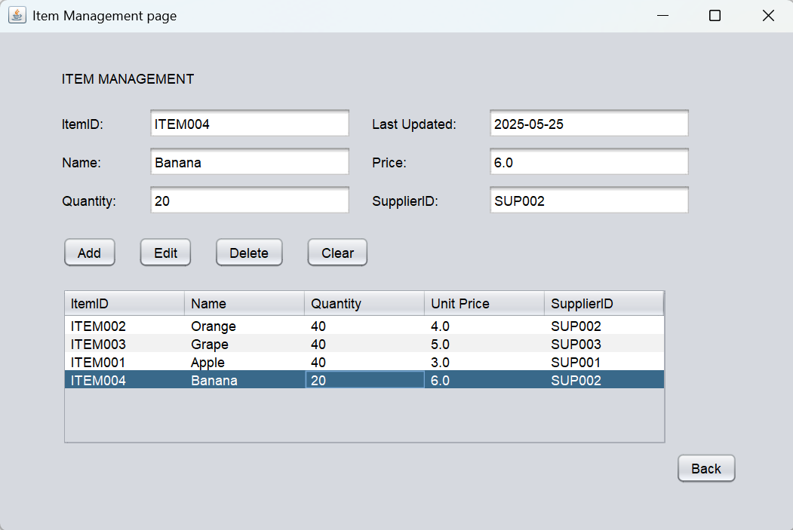

Figure 15 Sales Manager

When we close the message box, we can see that the quantity of the grape has been updated successfully.

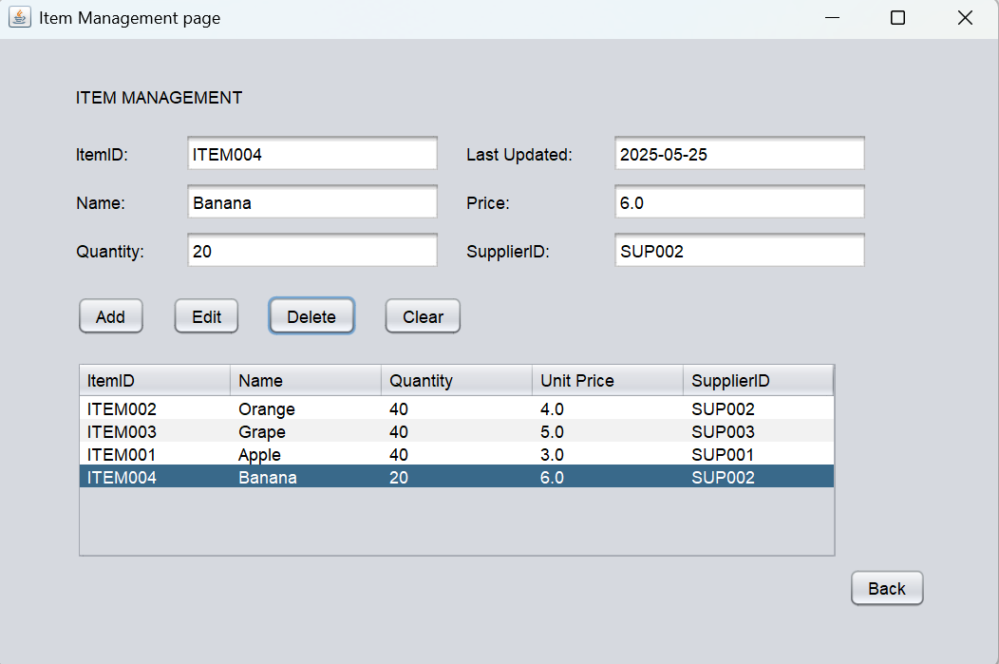

Figure 16 Sales Manager

Also, we can delete the item, we choose the item we want to delete from the table. And we can see the details will automatically fill in. Right now, we can just click on the Delete button to delete the item.

Figure 17 Sales Manager

After we click on the Delete button, it will prompt a confirmation message box to confirm that we are sure to delete the item, so we just click on the Yes button.

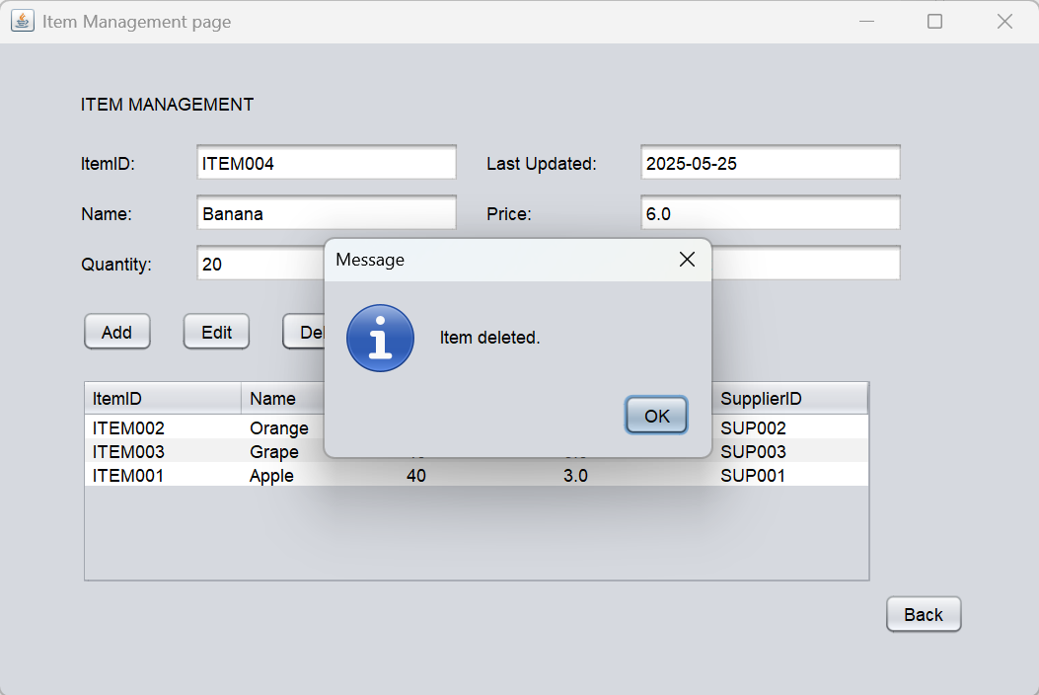

Figure 18 Sales Manager

It will show a message box after the item is deleted successfully, we click the OK button to close it.

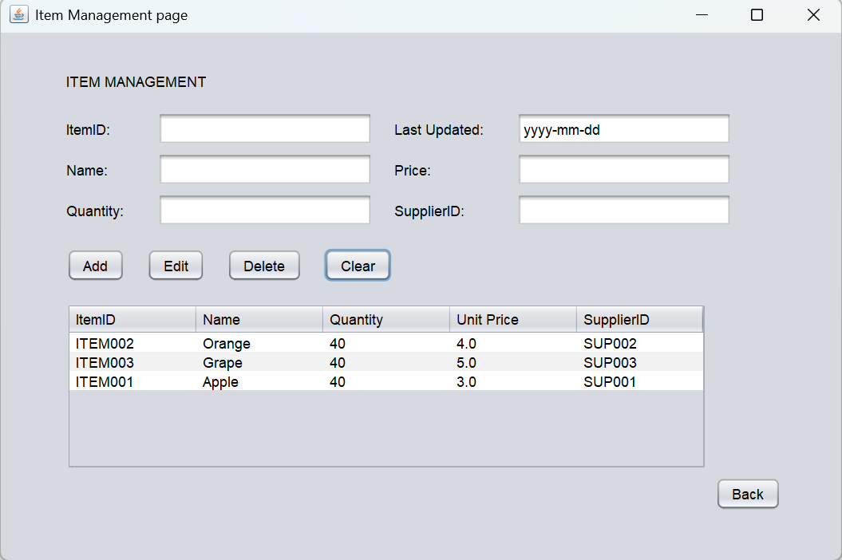

Figure 19 Sales Manager

When we click on the Clear button it will clear the information inside the textbox. Next, click on the Back button to go back to the menu.

**Supplier Management page**

We go to the sales manager menu and click on the Item Management button to go to the Item Management page.

Figure 20 Sales Manager

On the Supplier Management page we can also add, edit and delete the supplier. Right here we add a new item for the supplier 002 by click on the Add button.

Figure 21 Sales Manager

After the supplier added successfully, it will prompt a successful message box. We can click the OK button to close it.

Figure 22 Sales Manager

And we can see that the supplier has already upload into the table.

Figure 23 Sales Manager

Next, we edit the unit price of the grape which we have select in the table then we click on the Edit button.

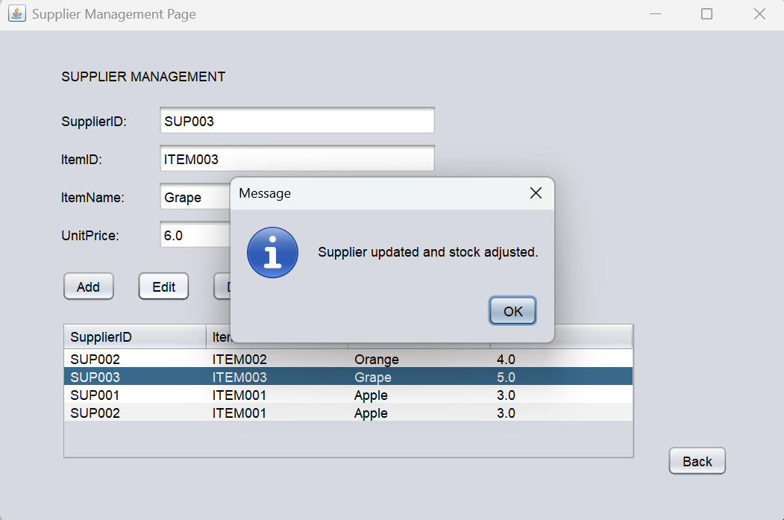

Figure 24 Sales Manager

If the edit was successfully, it will prompt a successful message. We close it by click on the OK button.

Figure 25 Sales Manager

And in the table, we can see that the unit price of the item has been edit to 6.0. We can also check the unit price in the item management.

Figure 26 Sales Manager

At the Item Management page, we can see that the unit price of the Grape change to 6.0. Which mean that the edit of the supplier Management was successful.

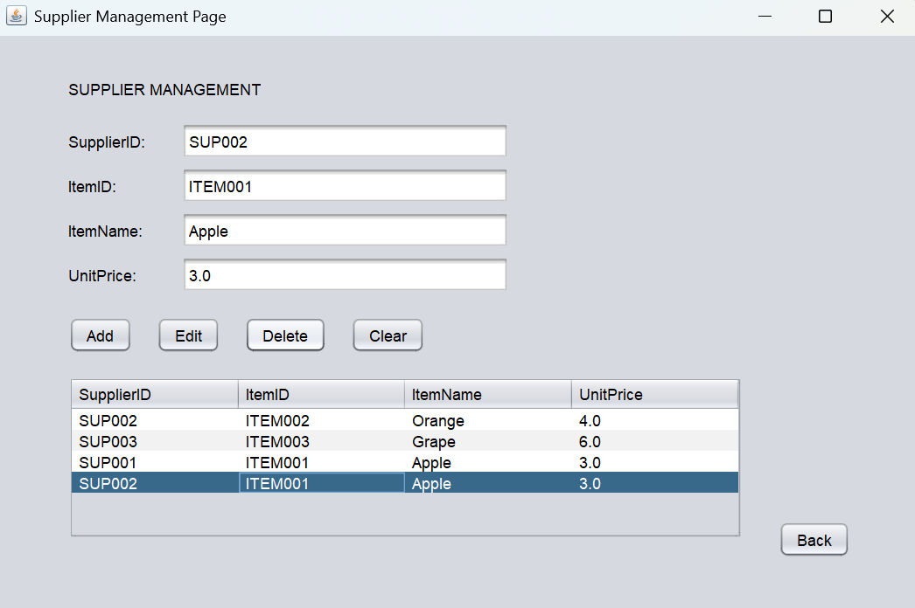

Figure 27 Sales Manager

After that, we go back to the Supplier Management and select the supplier in the table then click on the Delete button.

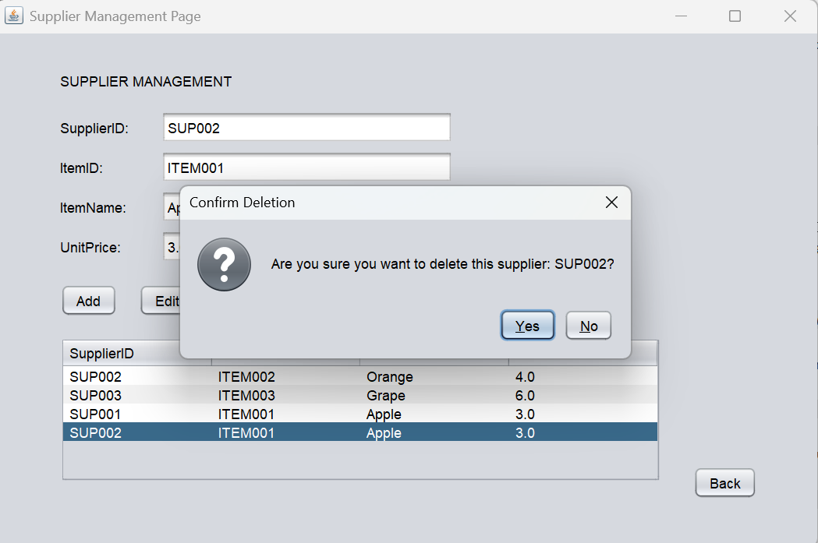

Figure 28 Sales Manager

It will prompt a confirmation message box for us, and we just click on the Yes button to proceed.

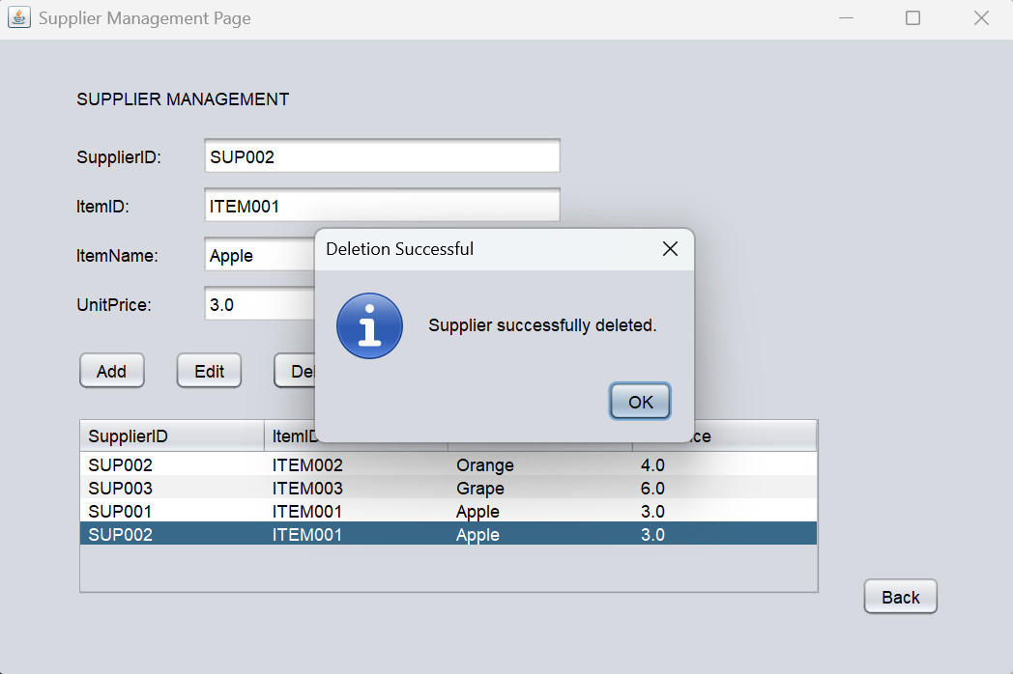

Figure 29 Sales Manager

After the deletion was successful it will prompt a message box to us, and we just click on the OK button to close it.

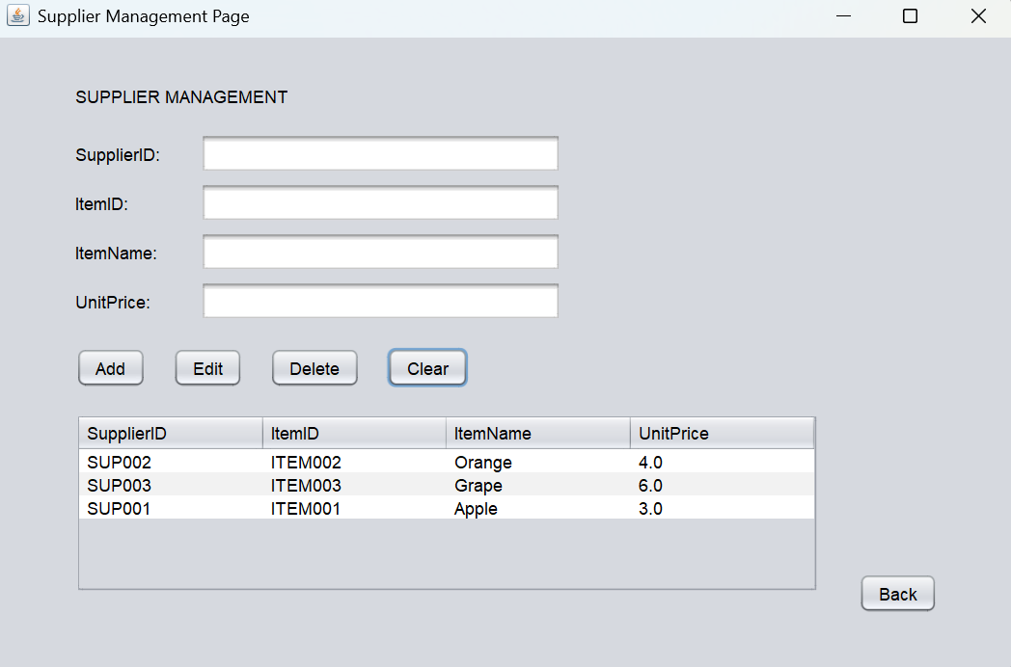

Figure 30 Sales Manager

The last button of the supplier Management is the Clear button, when we click on the Clear button it will clear the information inside the textbox. Next, click on the Back button to go back to the menu.

**Daily Sales Entry page**

We click on the Daily Sales Entry button on the Sales Manager menu to go to the Daily Sales Entry page.

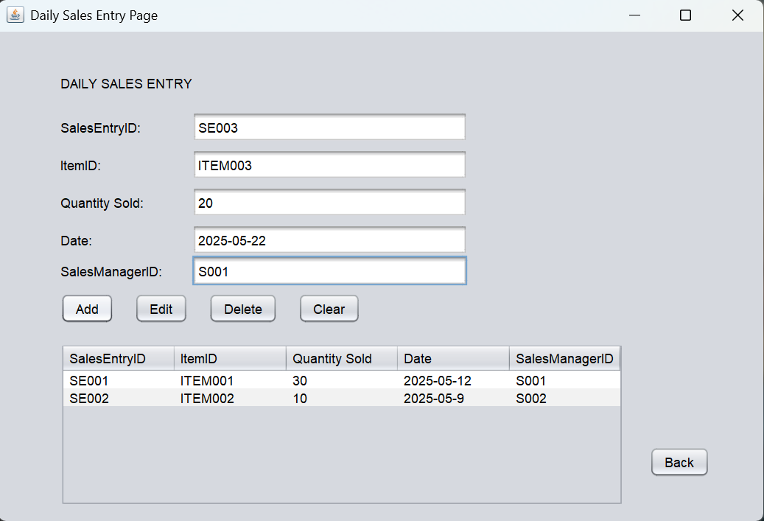

Figure 31 Sales Manager

On the Daily Sales Entry page we can also add, edit and delete the sales Entry. Right here we can create a new Sales entry by entering the details and then click on the Add button.

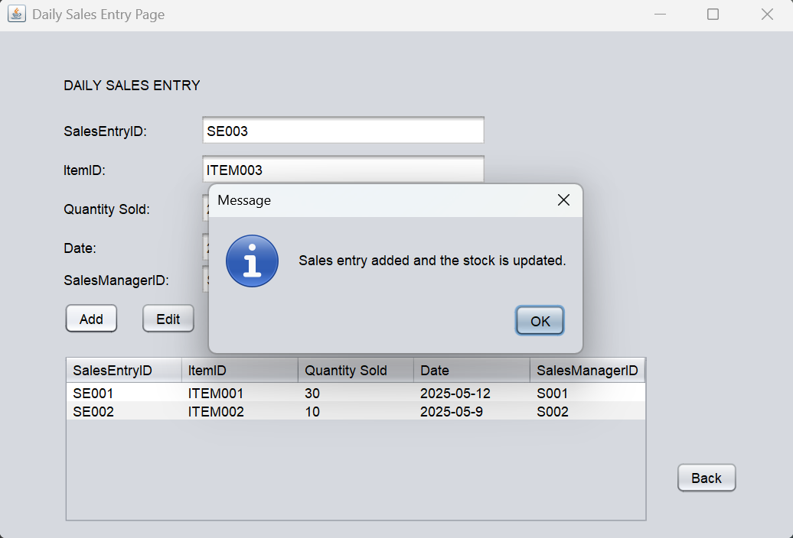

Figure 32 Sales Manager

If the new sales entry has been uploaded successfully it will prompt a message box for us. We just need to click on the OK button to close it.

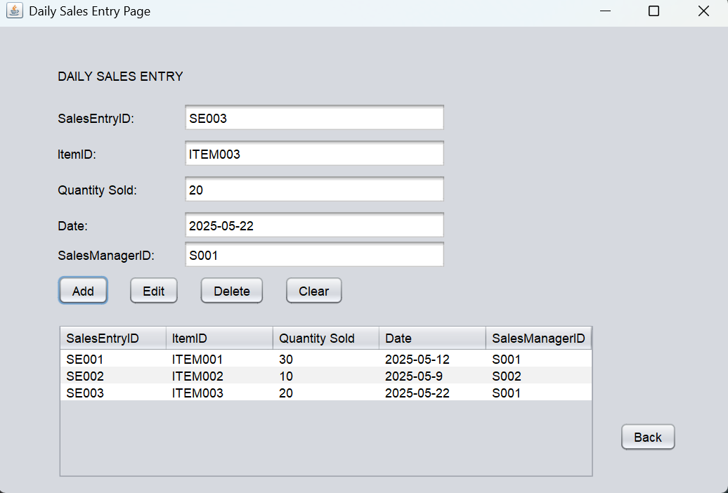

Figure 33 Sales Manager

And we can see that the new sales entry has uploaded into the table.

Figure 34 Sales Manager

Also, we can go to the Item Management page to make sure that the quantity of the grape has been updated.

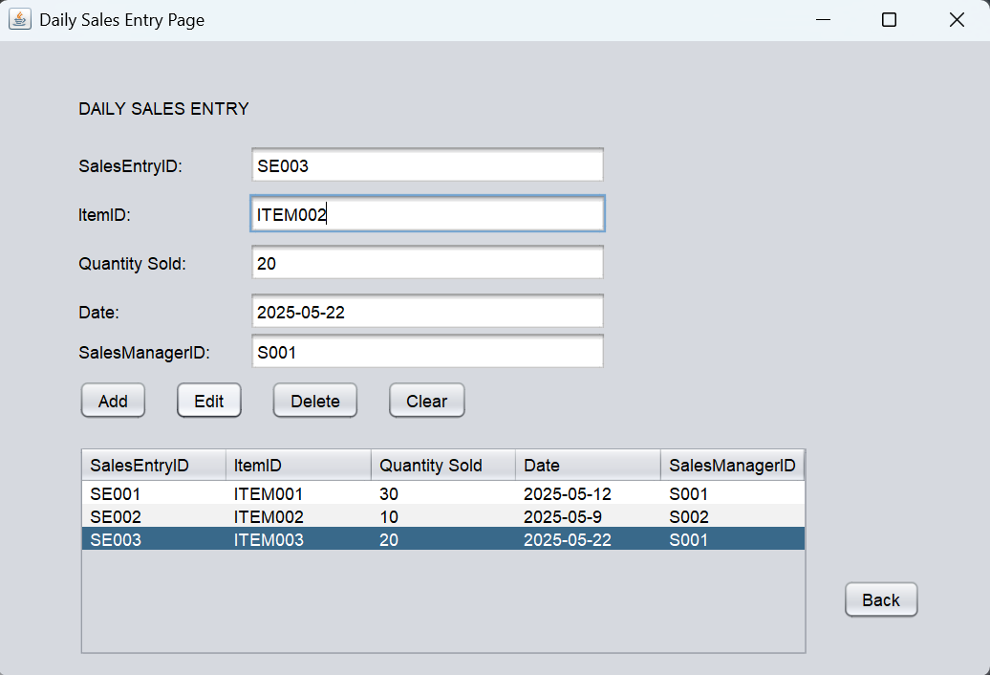

Figure 35 Sales Manager

Next, we edit itemID of the sales entry which was selected in the table then we click on the Edit button.

Figure 36 Sales Manager

If the edit of the sales entry is successfully, a successful message box will prompt. Click on the OK button to close it.

Figure 37 Sales Manager

After we close the message box, we can check the itemID of the sales entry has been updated into the table or not.

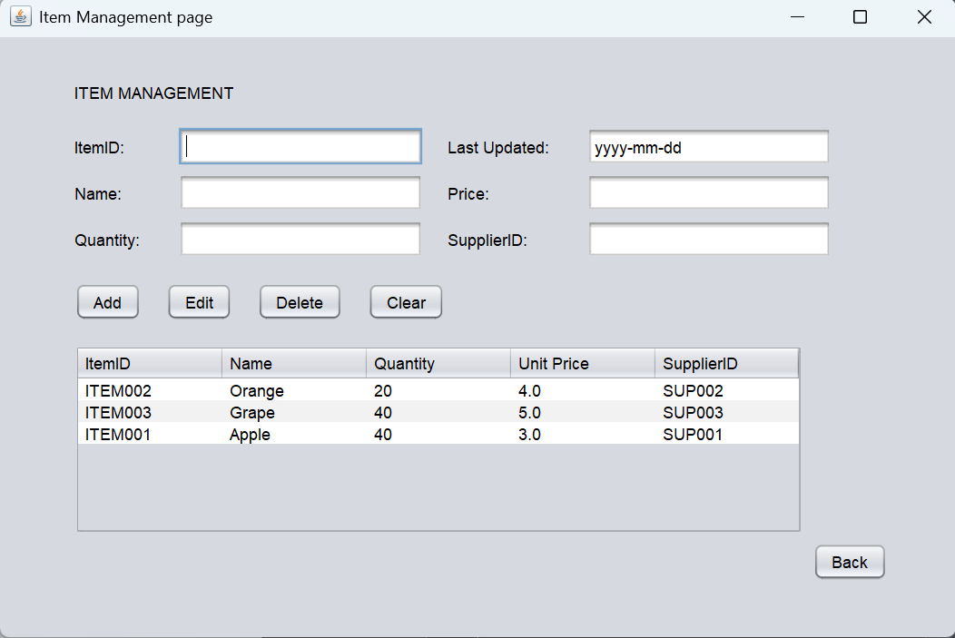

Figure 38 Sales Manager

Also, double check it at the Item Management page that the sales entry item has change to the orange.

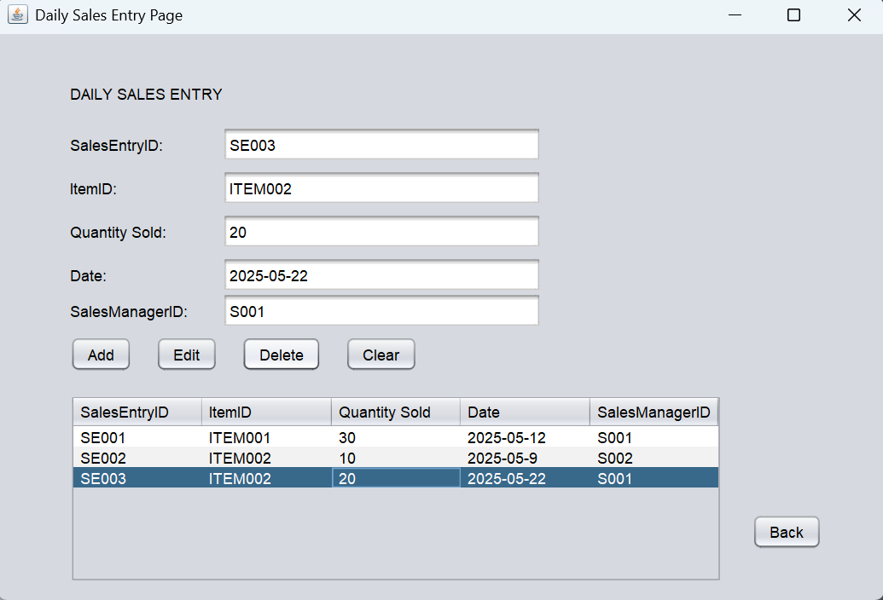

Figure 39 Sales Manager

Then select the sales entry in the table that we want to delete, then click on the Delete button to delete it.

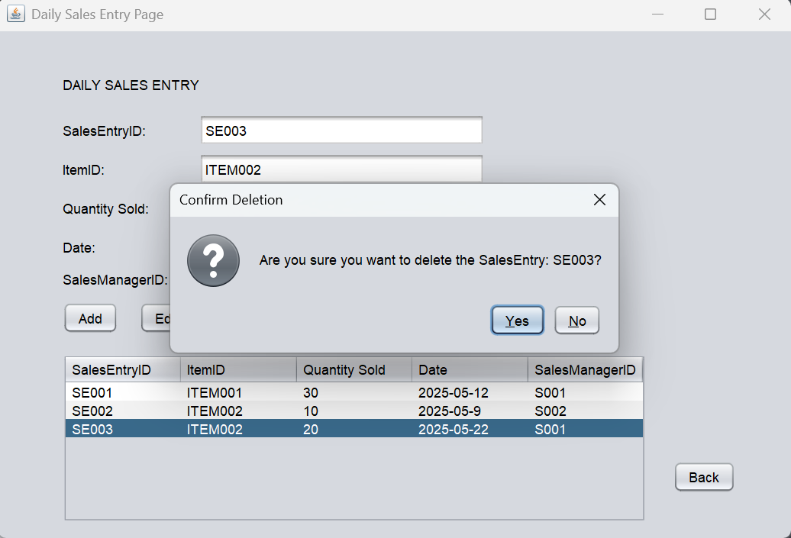

Figure 40 Sales Manager

When we click the Delete button, a confirmation message box will prompt out. Click on the Yes button to proceed it.

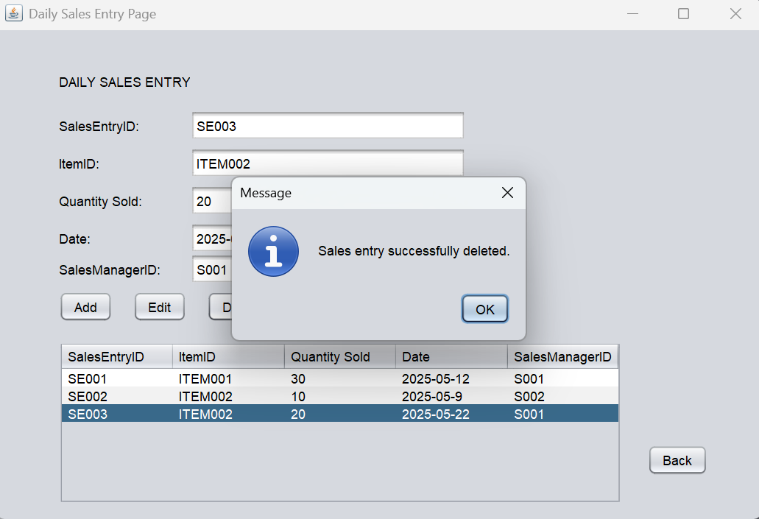

Figure 41 Sales Manager

After the deletion is successful, a successful message will prompt out. Click on the OK button to close it.

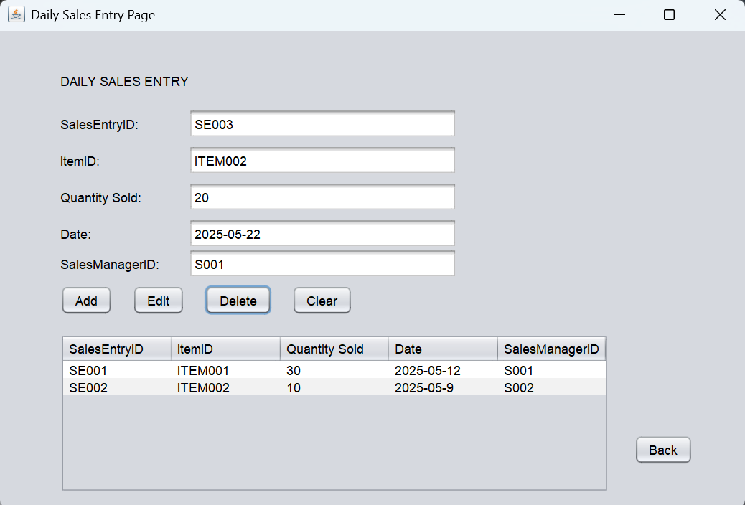

Figure 42 Sales Manager

The table will refresh when we close the message box.

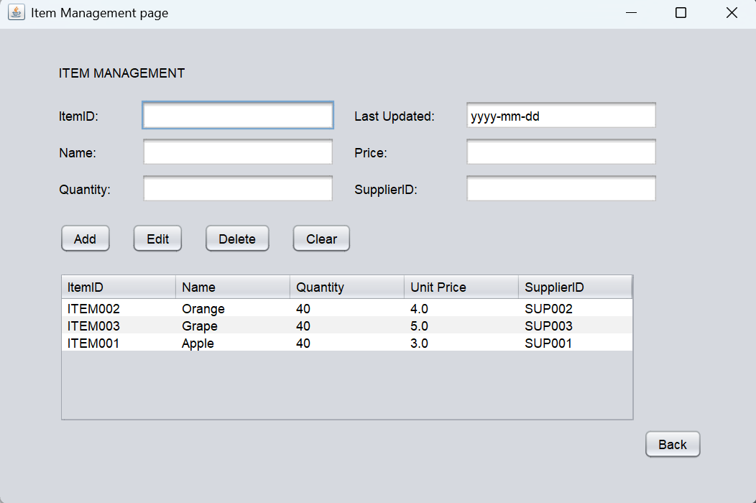

Figure 43 Sales Manager

When the deletion is successful, go to the Item Management page to double check the quantity of the item has uploaded or not.

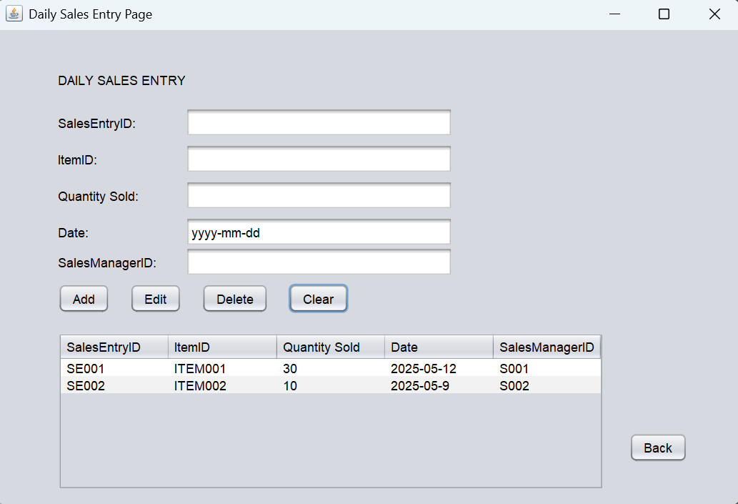

Figure 44 Sales Manager

Last is the Clear button, click on the Clear button it will clear the information inside the textbox. Next, click on the Back button to go back to the menu.

**Purchase Requisition page**

We click on the Purchase Requisition button on the Sales Manager menu to go to the Purchase Requisition page.

Figure 45 Sales Manager

On the Purchase Requisition page we can also view, add, edit and delete the purchase requisition. Right here we add a new purchase requisition click on the Add button.

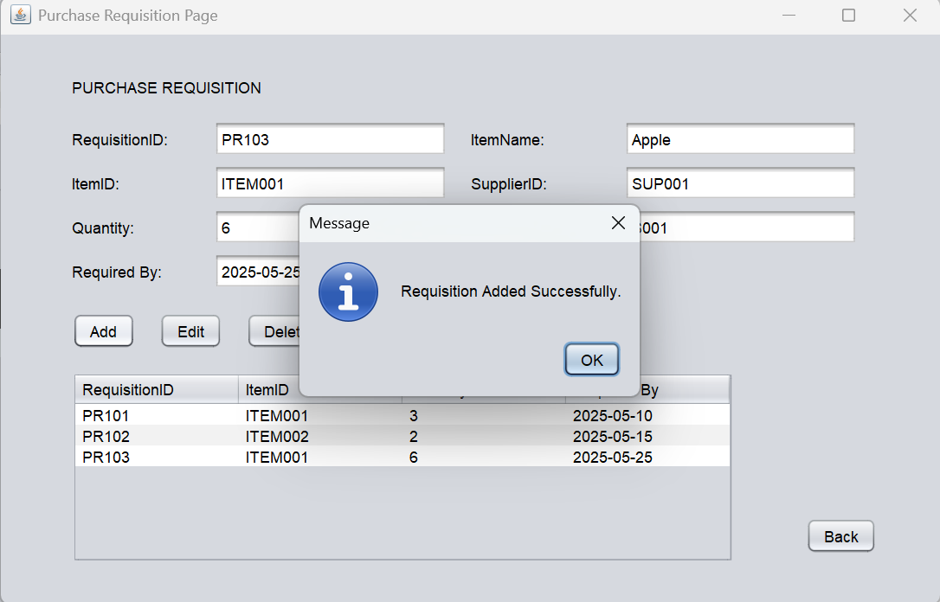

Figure 46 Sales Manager

When the purchase requisition is added successfully, it will prompt a successfully message box. Click on the OK button to close it.

Figure 47 Sales Manager

And we can see that the purchase requisition successfully uploaded into the table.

Figure 48 Sales Manager

Next, to edit the itemID, itemName and quantity of the purchase requisition. Click on the Edit button.

Figure 49 Sales Manager

If the edit is successfully, it will prompt a successful message box. Click on the OK button to close it.

Figure 50 Sales Manager

After that, we can see the updated purchase requisition in the table.

Figure 51 Sales Manager

Then select a purchase requisition in the table and click on the Delete button to delete it.

Figure 52 Sales Manager

When we click on the delete button, a confirmation message will prompt and we just need to click on the Yes button to proceed.

Figure 53 Sales Manager

When the deletion is successful, a successful message will prompt. And we can close it by click on the OK button.

Figure 54 Sales Manager

After that, we can see that the table has updated. The selected purchase requisition is deleted successfully. And we can go back to the menu by click on the Back button.

**Purchase Order page**

We click on the Purchase Order button on the Sales Manager menu to go to the Purchase Order page.

Figure 55 Sales Manager

In the Purchase Order page, we can search the purchase order by the Search button and view the purchase order at the table.

Figure 56 Sales Manager

Type in the purchase order ID and purchase requisition ID in the textbox, then click on the Search button. The correspond purchase order will show in the table and allow us to view the details of it.

Figure 57 Sales Manager

When we are typing the invalid ID for the purchase order and click on the Search button.

Figure 58 Sales Manager

It will prompt a message box show that no matching ID was found.

Figure 59 Sales Manager

And the table will not display any information because there is no corresponding data in it.

Figure 60 Sales Manager

So, we can click on the Clear button to refresh the table.

## 3.3 Purchase Manager

Figure 61 Purchase Manager

After we log in as Purchase Manager, the system will show Manager ID on the bottom, Log out button on top right, device time on down left and 5 functions button.

Figure 61 Purchase Manager

After clicking the Items List button, it will show the status of the current items.

Figure 62 Purchase Manager

After clicking the Suppliers List button, it will show the items are supplying by which supplier.

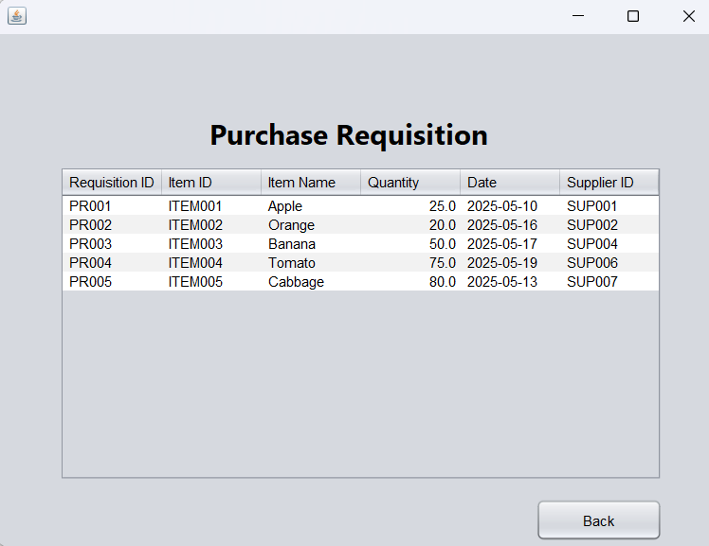

Figure 63 Purchase Manager

After clicking the Purchase Requisition button, it will show the data of the requisitions, so that Purchase Manager can create purchase order on it.

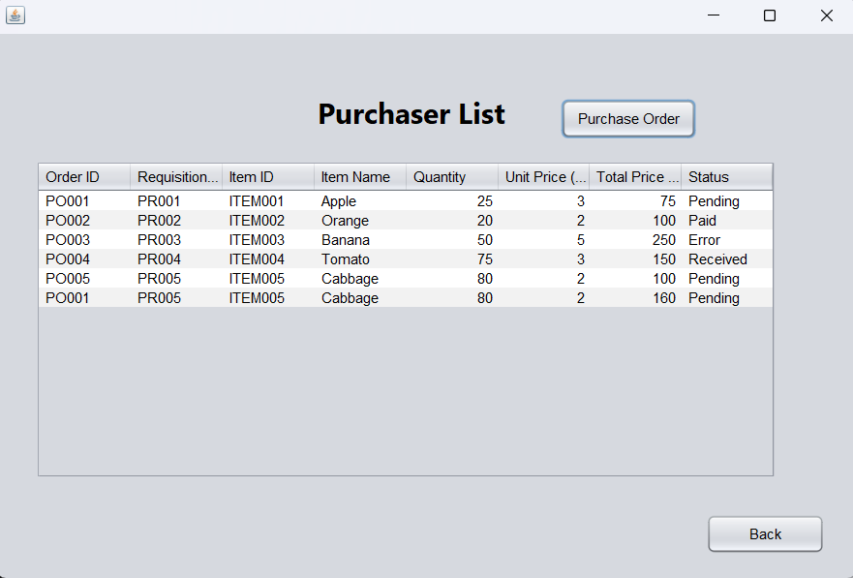

Figure 64 Purchase Manager

After clicking the Purchaser List button, it will show the status of purchase orders, so that Purchase Manager can make sure the data of purchase order are updated.

Figure 65 Purchase Manager

After clicking on the Generate Purchase Order button, it will show add, delete and edit purchase order.

Figure 66 Purchase Manager

In the Add Purchase Order page, Purchase Manager can select purchase requisition by its ID, after selecting, the page will show the requisition data, such as item ID, item name, supplier ID and quantity. To create a purchase order, Purchase Manager should type in its ID, Unit Price, Purchase Manager ID and Finance Manager ID. Purchase Manager can refer the requisition data by clicking on the view requisition button.

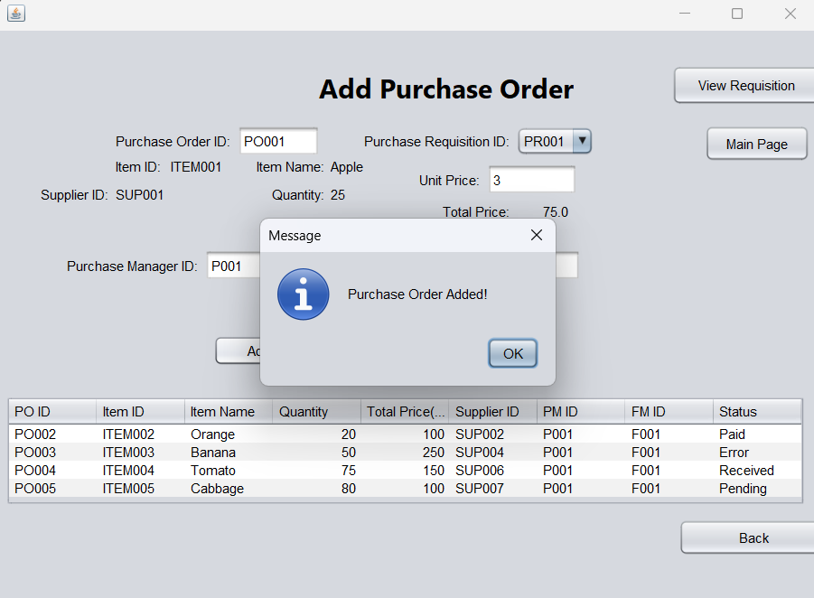

Figure 67 Purchase Manager

After completing the required data, Purchase Manager may click on the Add button to access the adding step.

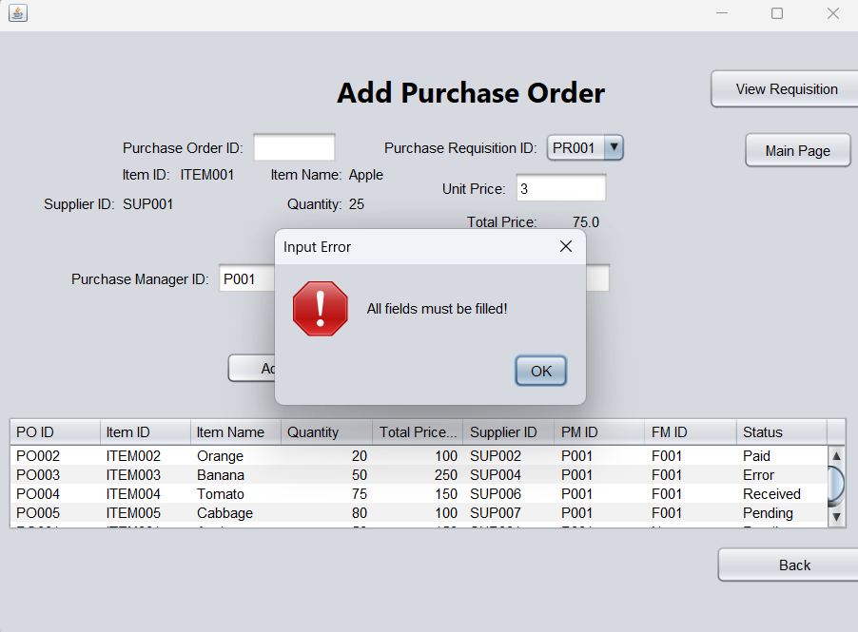

Figure 68 Purchase Manager

If any fields are blank then click the add button directly, system will show an error and notice user need to fill all the fields.

Figure 69 Purchase Manager

If the unit price is negative, system will show an error and notice the price must be positive number.

Figure 70 Purchase Manager

If the unit price is not an integer, system will show an error and notice the unit price must be an integer.

Figure 71 Purchase Manager

After adding the purchase order, it will show on the table, and the status will set as pending.

Figure 72 Purchase Manager

In the Delete Purchase Order page, Purchase Manager can delete any purchase order by selecting its Purchase Order ID.

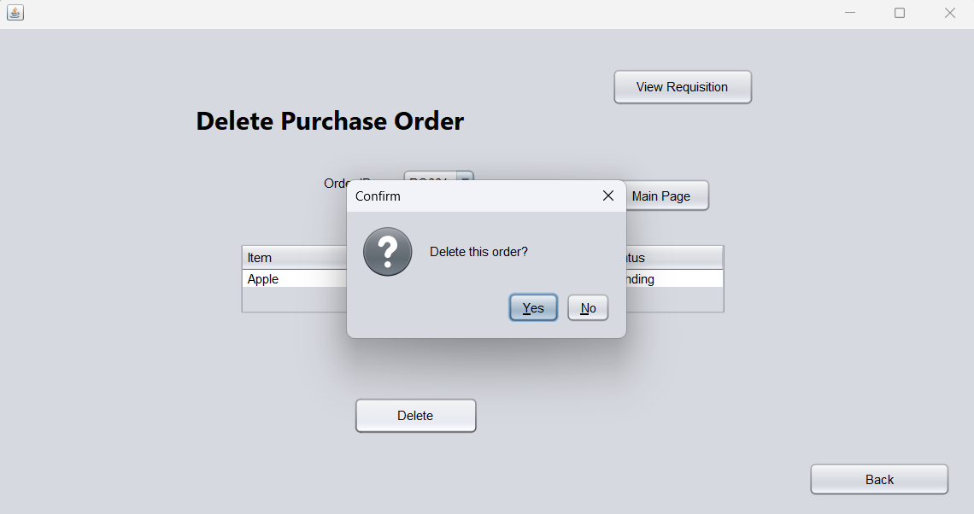

Figure 73 Purchase Manager

After selecting and click the delete button, system will show a confirmation to make sure the selected purchase order is the correct one.

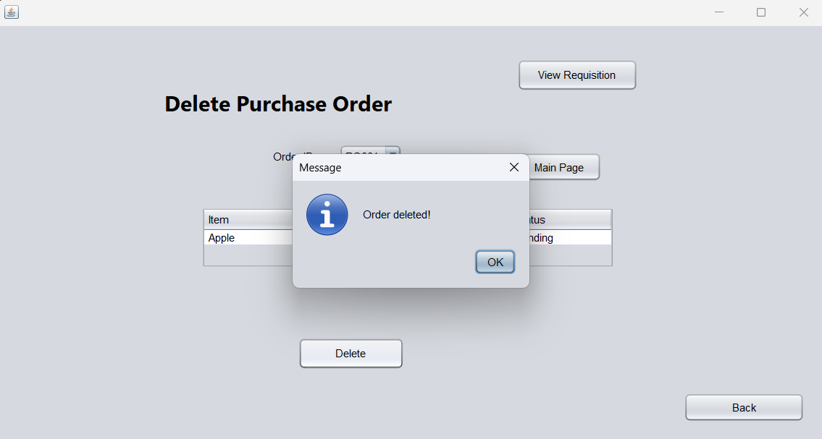

Figure 74 Purchase Manager

Click on the yes button, system will notice the chosen purchase order was deleted successfully.

Figure 75 Purchase Manager

In Edit Purchase Order page, Purchase Manager can select purchase order that need to edit by using its ID. Purchase Manager may change the quantity and Finance Manager ID of the selected purchase order.

Figure 76 Purchase Manager

After click on the update button, system will notice that the data of purchase order was updated successfully.

Figure 77 Purchase Manager

Figure 78 Purchase Manager

If the box are blanks, system will show an error, and which box is blanked after clicking the update button.

Figure 79 Purchase Manager

Figure 80 Purchase Manager

If the quantity is not an integer or positive numbers, system will show the error after clicking the update button.

## 3.4 Administrator

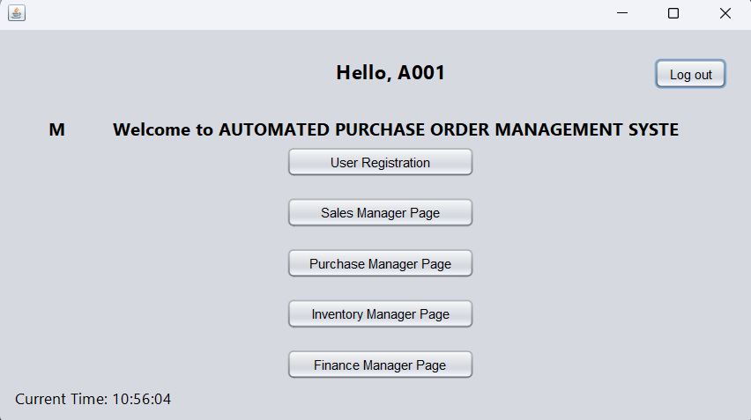

Figure 81 Administrator Menu

This is Administrator Menu.

Figure 82 Administrator User Registration

Administrator can add, edit and delete user accounts.

Figure 83 Administrator Add Account

Type the information in textfield then press add button, the account will create successfully.

Figure 84 Administrator Edit Account

Select a User in table then edit the information in textfield. After pressing the edit button, it will show updated successfully dialog.

Figure 85 Administrator Delete Account

Select a User in the table then press the delete button then it will show deleted successfully dialog.

## 3.5 Inventory Manager

Figure 86 IM Main Page

When the user logs in to inventory manager account with the correct credentials, the user will be brought to inventory manager main page. In inventory manager main page, the user can choose from “View Item List”, “View Purchase Order”, “Manage Stock Levels”, “Generate Stock Report” and “Log Out”.

Figure 87 IM View Item List Page

If the user selected “View Item List” in the main page, the user will be brought to “View Item List” page. The system will display a table showing all the items and the details of items stored in the database. The table is non-editable which means that the user can only view the item list. The user can click “Back” to return to the main page.

Figure 88 IM View Purchase Order Page

If the user selected “View Purchase Order” in the main page, the user will be brought to “View Purchase Order” page. The system will display an empty text field for the user to enter the purchase order ID of the purchase order the user wants to search, a “Search” button and an empty table.

Figure 89 Search with empty PO

If the user clicked “Search” without entering anything into the text field, the system will display a message telling the user to enter a purchase order ID.

Figure 90 Search with non-existing / invalid PO

If the user entered an invalid purchase order ID or a non-existing purchase order ID, the system will display a message telling the user that the purchase order ID entered is not found and ask the user to enter a valid purchase order ID.

Figure 91 Search with existing PO

If the user entered a valid purchase order that existed in the database, the table will display the details of the purchase order. The “Update Stock” button will be displayed based on the status of the purchase order.

Figure 92 Status Received

If the status of the purchase order is “Received”, it means that the purchase order is approved by finance manager and the received quantity is correctly updated. “Update Stock” button will not be displayed.

Figure 93 Status Error

If the status of the purchase order is “Error”, it means that the purchase order is approved by finance manager and the received quantity is updated but the received quantity is not the same amount as purchased quantity. “Update Stock” button will not be displayed.

Figure 94 Status Paid

If the status of the purchase order is “Paid”, it means that the purchase order is approved by finance manager and the received quantity is correctly updated, and the purchase order transaction has been made by finance manager. “Update Stock” button will not be displayed.

Figure 95 Status Approved

If status is “Approved”, the “Update Stock" button will be displayed and the table will be editable on the “Received Quantity” column. The user can enter the received quantity and click “Update Stock” button to update the received quantity to item database and update the status of the purchase order.

Figure 96 Negative received quantity

If the user entered a negative number of received quantity, then clicked “Update Stock” button, the system will display a message telling the user which row has error and the received quantity cannot be negative.

Figure 97 Received quantity matches purchase quantity

If the user entered received quantity not less than 0, the system will display a confirmation message asking the user if the user want to update the purchase order. The user can choose yes to proceed the update or no to cancel the process.

Figure 98 Update successful message

If the user selected “Yes” in the confirmation message, a message will be displayed telling the user that the purchase order is updated successfully.

Figure 99 Updated table

The table in “View Purchase Order” page will also be updated to the latest version showing the newly updated status and the updated received quantity after the update successful message is displayed.

Figure 100 Another approved purchase order

Figure 101 Received quantity does not match purchase quantity

Figure 102 Mismatch Warning

If the user entered received amount that does not match the purchase order and clicked “Update Stock” button. The system will display a “Mismatching Warning” message telling the user which rows’ received amount does not match with the purchase amount. The user can click “Yes” to continue the update or “No” to cancel the update process.

Figure 103 Update successful message

If the user selected “Yes” in the mismatch warning message, a message will be displayed telling the user that the purchase order is updated successfully.

Figure 104 Updated table

The table in “View Purchase Order” page will also be updated to the latest version displaying the newly updated status and the updated received quantity after the update successful message is shown. The status is changed to “Error” indicating the received quantity does not match the purchase quantity.

Figure 105 IM Manage Stock Levels page

If the user selected “Manage Stock Levels” in the main page, the user will be brought to “Manage Stock Levels” page. The system will display a table showing all the items and the details of items stored in the database. The table is editable on “Quantity” column, which means the user can edit the quantity of the items. The user can click “Back” to return to the main page.

Figure 106 Alter quantity

After the user altered the table, “Reset” button and “Confirm” button will be displayed for the user to choose the next move.

Figure 107 Confirm update message

A confirmation message will be displayed asking the user if the user wants to update the stock levels. The user can select “Yes” to proceed the update or “No” to cancel the update.

Figure 108 Updated table

The quantity of the item is updated. If the quantity of the item is not more than 10, the Low-Stock Alert box will be ticked, indicating the item is in low-stock status.

Figure 109 Alter quantity

Figure 110 Confirm reset message

If the user altered the table and clicked “Reset” button, a confirmation message will be displayed asking if the user want to reset all received quantities, the user can select “Yes” to reset the table or “No” to cancel the reset.

Figure 111 Reset table

If the user selected “Yes”, the table will be reset to current quantity and the “Reset” button and “Confirm” button will not be visible.

Figure 112 Alter quantity to more than 10

Figure 113 Confirm update message

Figure 114 Updated table

If the user changed the item quantity from not more than 10 to more than 10, the Low-Stock Alert box will be unticked, indicating the item is not in low-stock status.

Figure 115 IM Generate Stock Report page

If the user selected “Generate Stock Report” in the main page, the user will be brought to “Generate Stock Report” page. The system will display the report ID, report type, who generated the report, what date is the report generated, a table displaying all the items and the details of items stored in the database, and “Save” button The table is non-editable, meaning the user can only view the table. The user can click “Back” to return to the main page.

Figure 116 Confirm save stock report message

If the user clicked “Save” button, the system will display a confirmation message asking the user if the user wants to save the stock report. The user can select “Yes” to save the stock report or “No” to cancel the process.

Figure 117 Stock report saved message

If the user selected “Yes”, the system will display a message telling the user the report is save and the name of the report.



Figure 118 Stock report saved in folder

In Stock Report folder in the PC, the user can view the stock reports saved.

Figure 119 Stock report content

The content of the report will be displayed if the user open the CSV file.

Figure 120 IM log out

In the main page, if the user wanted to log out, the user can click “Log Out” button. A confirmation message will appear. The user can select “Yes” to log out or “No” to cancel the log out.

## 3.6 Finance Manager

Figure 121 Finance Manager Menu

When the user enters the financial manager's credentials, they will be directed to this menu and can select the function.

Figure 122 Logout

When the user clicks the logout button, a confirmation window will pop up.

Figure 123 Verify Purchase Order

This is the purchase order verification page.

Figure 124 Search PO ID

User can enter PO ID to filter the table.

Figure 125 Edit Purchase Order

When the user selects a purchase order line, they can change the quantity, supplier, approve or reject it.

Figure 126 Select Supplier

When the user clicks on the combo box, they can view the suppliers that supply this item.

Figure 127 different unit price

Different suppliers have different prices.

Figure 128 Confirm Edit Changes

When a user wants to change a purchase order, a pop-up window will appear asking for confirmation.

Figure 129 Update Successfully

When the user confirms, a window will appear indicating that the operation is successful.

Figure 130 Request user confirmation to approve purchase order

When the user clicks the approve button, a window will pop up requesting confirmation.

Figure 131 Update Successfully

When the user confirms, a window will appear indicating that the operation is successful.

Figure 132 Request user confirmation to reject purchase order

When the user clicks the reject button, a window will pop up requesting confirmation.

Figure 133 Update Successfully

When the user confirms, a window will appear indicating that the operation is successful.

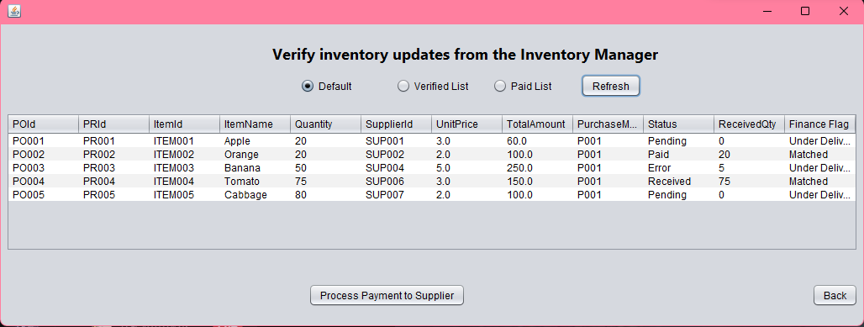

Figure 134 Verify Inventory Updates

This is the stock update verification page. The Finance Flag column will show whether the ordered quantity and the received quantity are the same. If they are the same, the word "Matched" will be displayed. If they are not the same, "Under Delivery" or "Over Delivery" will be displayed. The received quantity is updated by the inventory manager.

Figure 135 Verified List

The radio button can filter the table. When "Verified List" is selected, the data with the status of "Received" will be displayed.

Figure 136 Paid List

When "Paid List" is selected, the data with the status of "Paid" will be displayed.

Figure 137 Request user confirmation to process payment

When the user selects a verified purchase order and clicks process payment, a confirmation window will pop up.

Figure 138 Payment Complete

When the user confirms, a window will appear indicating that the operation is successful.

Figure 139 Financial Report

This is the financial report page where you can view your expenditure, outstanding orders and the budget for the month.

Figure 140 Select Directory to save csv file

When you click the Export CSV button, you can choose where to save the file.

Figure 141 Export Successfully

When the csv file is successfully saved, a window will pop up indicating that the operation was successful.

Figure 142 CSV file

This is the csv file opened in excel.

Figure 143 View Purchase Requisitions

This is the purchase requisition page. The refresh button can redisplay all the data in the table.

Figure 144 Using Item id to Filter

The radio button can filter the form data. When "Item Id" is selected, enter ITEM003 in the text box and the corresponding data will appear.

Figure 145 Using Supplier Id to filter

When "Supplier Id" is selected, enter SUP001 in the text box and the corresponding data will appear.

# 4.0 Object Oriented Concepts

## 4.1 Encapsulation

Figure 146 Purchase Order Class

Figure 147 Purchase Order getter and setter

Encapsulation is one of the principles of object-oriented programming. By making class fields private, they cannot be directly accessed from outside and can only be accessed and modified through public getter and setter methods. From the above figure, we can see that by defining variables as private and getter/setter methods, they can be accessed from outside.

Figure 148 Fields are Initialized

We use a constructor to encapsulate the creation of an object when reading data from a text file. This ensures that all fields are initialized correctly. Once the object is created, it is not modified by accessing the fields directly.

Figure 149 Using Getter to get the data

The above image shows that we use public getter methods in the code to input data into jTable so order.poId is never accessed directly. This is the real power of data protection.

Figure 150 Using Setter to update data

The above picture shows that we use the public setStatus() to update the data in the code instead of directly executing order.status = "Approved". This improves the security, readability and maintainability of the code. In addition, in this automated purchase order management system, all data read from the text file, displayed in the table, and updated in memory are completed through constructors, getters and setter methods.

## 4.2 Inheritance

Figure 151 Inheritance for User Class

Inheritance is also one of the object-oriented concepts. In Java, only single inheritance is possible, which means that properties and methods are inherited from one class to another. Java does not support multiple inheritance. To inherit from a class, you need to use the extends keyword. In the above figure, User is our super class, and its properties and methods can be shared.

Figure 152 FinanceManager Sub Class

In the above picture, Finance Manager Class inherits from the User class. It reuses the fields and methods in the User class such as userId, password. It provides its own version of openDashboard() to display its own role's dashboard. Besides, we inherit from User in each role's class and open its own dashboard.

Figure 153 Inheritance Usage Examples

In the above figure, when a user logs in, User.authenticate() returns a User object (which could be any role) and then openDashboard() is dynamically called, executing the correct subclass method. In summary, using inheritance in this automated purchase order management system facilitates code reuse, logical hierarchy, abstraction and simplification of subclasses such as FinanceManager to only implement its unique features openDashboard(), polymorphism, and extensibility.

Figure 154 InvalidNumberException Custom Exception

The above figure shows the use of custom exception handling. InvalidNumberException Class inherits from Exception so that we can create custom, more meaningful error types. For example, this exception is to verify whether the number is negative.

Figure 155 Implement InvalidNumberException Exception

We write this exception in the setter so that when the user modifies the quantity, if it is a negative number, it will be thrown. In this automated purchase order management system, any attribute that modifies the number will use this exception.

## 4.3 Polymorphism

### 4.3.1 Overriding

Figure 156 FMTableLoader Class

Polymorphism in Java is mainly divided into overriding and overloading. Overriding, also known as runtime polymorphism, means that a subclass provides its own version of a method defined in its superclass with the same name, return type, and parameters. In the above figure, the super class FMTableLoader defines the loadTable() abstract method.

Figure 157 Method Overriding in FMVerifyPurchaseOrder Class

Figure 158 Method Overriding in FMVerifyInventory Class

In the above figures you can see two subclasses. Both subclasses override the loadTable() method but implement it in different ways according to their needs. In this system, we use polymorphic overriding methods to import data into the table. The openDashboard() mentioned in the inheritance section is also an override method. In summary, using overriding allows each subclass to define its own version of loadTable() to achieve specific behaviour, code reuse, flexibility, and scalability.

Figure 159 Call in GUI

The above picture is implemented in the GUI code. FMVerifyInventory is a subclass of FMTableLoader. Although the superclass method is loadTable(), it calls the overridden method in FMVerifyInventory. The data will be added to the DefaultTableModel that the GUI is using.

### 4.3.2 Overloading

Figure 160 loadTable() Method Overloading

Figure 161 loadTable() Method Overloading

Overloading is also called compile-time polymorphism. It is a method with the same name but different parameter lists, such as type, quantity or order. In the above picture, one loadtable has no parameters and the other has List<PurchaseRequisition> parameters. We use overloading here to filter data. We can see that there are overloaded methods called in loadTableByItemId(String itemId) and loadTableBySupplierId(String supplierId).

Figure 162 Call in GUI

The above figure shows that we implemented two versions of loadTable() in the GUI code: one version without parameters (for loading all data) and the other version with parameter list (for loading filtered data). This design improves flexibility, simplifies the use of methods, and reduces code duplication, making the system easier to read, use, and expand.

## 4.4 Abstraction

### 4.4.1 Abstracts

Figure 163 Abstract User Class

Abstraction is hiding the details of reality and only showing the basic features of an object to the user. In Java, abstraction can be achieved through abstract classes or interfaces. In the above picture, the User abstract class is defined, which means it cannot be directly instantiated. There is also an abstract method openDashboard(), which has no method body and must be implemented by subclasses.

Figure 164 Implementation of openDashboard() abstract method in Administrator Class

In the above figure, Administrator provides a concrete implementation of openDashboard(), which is the abstract method of User. In addition, we also use the same method to implement the abstract method of user in each role class. This ensures that all user types follow a consistent structure. Abstraction improves code organization, reduces duplication, and makes the system easier to extend and maintain.

### 4.4.2 Interfaces

Figure 165 ReportGenerator Interface

The Java interface only defines the method signature and does not include the specific implementation. This is a strong form of abstraction that only shows "what to do" rather than "how to do it". The above figure defines the common behaviour that all report classes must provide.

Figure 166 Implementation of generateReport() interface method in FMFinanceReport Class

To access the interface, use the implements keyword. In the above figure, FMFinanceReport provides a concrete implementation of generateReport().

Figure 167 ReportGenerator Interface Usage

In the above figure, the interface ReportGenerator is used to apply abstraction instead of FMFinanceReport. This approach is also used in the FMSupplierPerformanceReport class. In summary, by defining a common method generateReport(), any class responsible for generating a report must implement this method. This improves flexibility, modularity, and future extensibility.

# 5.0 Additional Features

## 5.1 Finance Manager Monthly Budget Features

Figure 168 Monthly Budget Update Page

When you click the "update budget" button, you will be redirected to the page shown in the figure above. This allows you to view the budget for each month.

Figure 169 Select Month

Click the combobox to select a different month, and the label will display the budget based on the selected month.

Figure 170 Ask User Confirmation

After selecting the month and entering the budget amount, a window will pop up to request confirmation.

Figure 171 Update Successfully

When the user confirms, a window will pop up indicating successful operation.

Figure 172 Show Error Dialog When Select Past Month

In addition, if you select a previous month to update the budget, a window will pop up indicating that the update is not possible.

## 5.2 Finance Manager Supplier Performance Report

Figure 173 Supplier Performance Report

The financial manager can view the supplier's performance report to check whether the supplier is reliable and whether to continue purchasing from the supplier in the future.

# 6.0 Limitation

This automated purchase order management system has limitations. For example, the data is stored in text files, which may cause data corruption. When the data is lost, there is no backup function. The scalability is poor, and the operation speed will slow down when the amount of data is large. Then, this system also has security issues because the password is stored in text form without encryption, which makes it easy for outsiders to obtain the password. There is also a lack of access log records, which makes it impossible to track what operations users perform. Furthermore, the system architecture is limited to single-user use and does not support multiple users. In addition, since this system uses java swing to design the basic GUI, the user experience is not good.

# 7.0 Conclusion

This Automated Purchase Order Management System (OWSB) demonstrates the integration of five roles such as sales manager, purchasing manager, administrator, inventory manager, and financial manager. These roles can use their own functions after entering their own credentials. The system can automatically detect how much inventory is left and make purchases, making the purchase process more efficient and convenient for OWSB wholesalers.

To implement the functions of these five roles, we applied object-oriented programming concepts such as encapsulation, inheritance, polymorphism, and abstraction to ensure modularity, reusability, and maintainability. File I/O is also used to allow users to change or store data in text files and exception handling to avoid logical errors is also applied in the code. Although the system now meets the basic functions, there are still many areas that can be improved such as database integration, security enhancements, and real-time functions can significantly improve scalability and robustness.

# 8.0 Workload Matrix

|  |  |  |  |
| --- | --- | --- | --- |
| Student Name | TP Number | Task | Percentage |
| Yaw Kai Yuan | TP080121 | - Finance Manager  - Login  - Administrator Function  - Combine Source Code  - Explain Object Oriented Concept | 20% |
| Er Chen Liang | TP080254 | - Sales Manager | 20% |
| Voon Yue Cheng | TP080509 | - Inventory Manager | 20% |
| Huang Xiao Shun | TP077723 | - Administrator | 20% |
| Chong Wai Kit | TP080388 | - Purchase Manager | 20% |

# 9.0 References

GeeksforGeeks. (2024, July 30). *Introduction to Java Swing*. <https://www.geeksforgeeks.org/introduction-to-java-swing/>

GeeksforGeeks. (2021, October 12). *Java Swing | JTable*. <https://www.geeksforgeeks.org/java-swing-jtable/>

GeeksforGeeks. (2025, March 25). *Exceptions in Java*. <https://www.geeksforgeeks.org/exceptions-in-java/>

GeeksforGeeks. (2025, April 14). *Object-oriented programming (OOPs) concept in Java*. <https://www.geeksforgeeks.org/object-oriented-programming-oops-concept-in-java/>

Tutorialspoint. (n.d.). *Java - Files and I/O.* <https://www.tutorialspoint.com/java/java_files_io.htm>

W3Schools. (n.d.). *Java classes and objects*. W3Schools. <https://www.w3schools.com/java/java_classes.asp>